How To Run This Program

1. Run Makefile with make command to compile

2. Run server executable to start server

3. Run client executable to start client

4. Follow on screen instructions

How To Test

1. Change the defined KEY value in either server or client to a different number

2. Run the Program as normal to obtain a "False" result

Test For True Result

Input: This is a test

Output: True

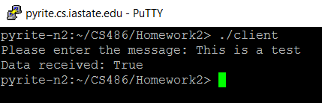

Test For False Result (Key on server = 2, key on client = 3)

Input: This is a test

Output: False

